ECAO3O5- SIGNALS AND SYSTEMS
NAME: S.GOKUL
REG NO: 192512373
Experiment No.: 7
Title: Continuous-Time Fourier Transform and Spectrum Analysis
Objective (ii) :To determine the magnitude and phase spectra of continuous-time signals and analyze their significant spectral components.
AIM
To determine the magnitude and phase spectra of a continuous-time signal (Gaussian-modulated cosine) and analyze its significant spectral components using MATLAB.
APPARATUS / SOFTWARE REQUIRED
1. Computer / Laboratory PC
2. MATLAB software (with Signal Processing environment)
THEORY
The Fourier transform X(f) of a continuous-time signal x(t) gives its frequency-domain representation. X(f) is complex, and it is described by its magnitude spectrum |X(f)| and its phase spectrum ∠X(f).
The signal x(t) = e^(−t²) cos(2π·3t) is a Gaussian pulse modulated by a 3 Hz cosine. The Gaussian pulse has a Gaussian spectrum, and the modulation shifts it to ±3 Hz, so X(f) = (√π/2)[e^(−π²(f−3)²) + e^(−π²(f+3)²)]. The magnitude spectrum therefore has two symmetric peaks at ±3 Hz. In MATLAB the transform is approximated by X(f) ≈ Δt·FFT{x}, shifted with fftshift, and the frequency resolution is Δf = 1/(NΔt).
FORMULAE USED
X(f) = ∫ x(t) e^(−j2πft) dt
Magnitude spectrum = |X(f)|; Phase spectrum = ∠X(f)
FFT approximation: X(f) ≈ Δt · FFT{x[n]}, Δf = 1/(N Δt)
ALGORITHM / PROCEDURE
- Start MATLAB and define the time vector t = −2 to 2 s with a step of 0.001 s.
- Generate the signal x(t) = e^(−t²) cos(2π·3t).
- Compute the FFT of x(t) with N = 4096 points, scale it by Δt and shift it using fftshift.
- Form the frequency axis f = (−N/2 : N/2 − 1)/(N Δt).
- Calculate the magnitude spectrum and the unwrapped phase spectrum.
- Plot the signal, the magnitude spectrum and the phase spectrum, limiting the frequency axis to ±10 Hz.
- Identify the principal spectral peaks.
INPUT PARAMETERS
S.No. | Input Parameter | Symbol / Setting | Value | Unit
1 | Time range | t | −2 to 2 | s
2 | Time step | Δt | 0.001 | s
3 | Carrier frequency | f_c | 3 | Hz
4 | FFT length | N | 4096 | samples

PROGRAM (MATLAB CODE)
clc; clear; close all;
%% 7(ii) Determination of Magnitude and Phase Spectra of Continuous-Time Signals
figure;
% Magnitude and Phase Spectrum of a CT Signal
t = -2:0.001:2;
dt = t(2)-t(1);
x = exp(-t.^2).*cos(2*pi*3*t);
N = 4096;
X = fftshift(fft(x,N))*dt;
f = (-N/2:N/2-1)/(N*dt);
magX = abs(X);
phaseX = unwrap(angle(X));
subplot(3,1,1);
plot(t,x); grid on;
xlabel('Time (s)'); ylabel('Amplitude');
title('Continuous-Time Signal');
subplot(3,1,2);
plot(f,magX); xlim([-10 10]); grid on;
xlabel('Frequency (Hz)'); ylabel('|X(f)|');
title('Magnitude Spectrum');
subplot(3,1,3);
plot(f,phaseX); xlim([-10 10]); grid on;
xlabel('Frequency (Hz)'); ylabel('Phase (rad)');
title('Phase Spectrum');
OUTPUT
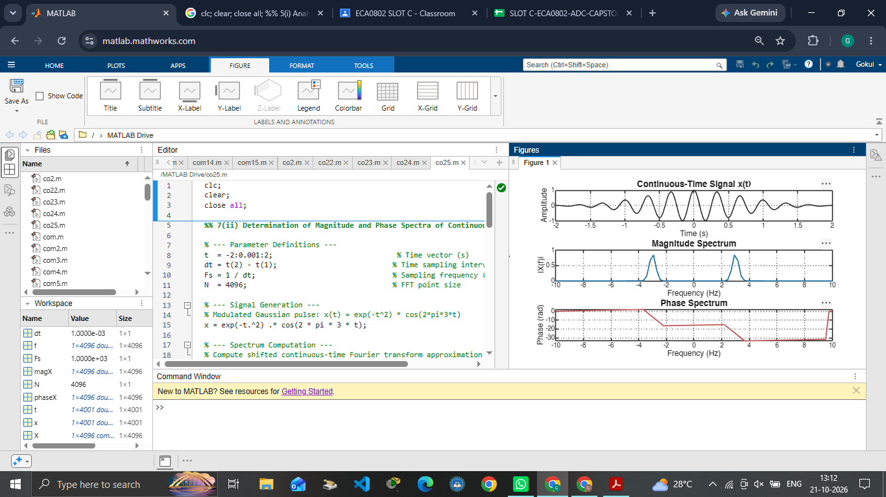
Fig. 7.1 Time-domain signal, magnitude spectrum and phase spectrum
OUTPUT PARAMETERS (THEORETICAL vs SIMULATED)
S.No. | Output Parameter | Theoretical Value | Simulated Value | % Deviation
1 | Time-domain signal | e^(−t²)cos(2π3t) | Gaussian envelope with 3 Hz carrier | Qualitative match
2 | Magnitude spectrum | |X(f)|: two peaks | Two symmetric peaks | Qualitative match
3 | Phase spectrum | ∠X(f) | Recorded plot | Qualitative match
4 | Spectral peak frequency | ±3 Hz | ±2.93 Hz | 2.3 %
5 | Peak magnitude | √π/2 = 0.886 | 0.841 | 5.1 %*

RESULT
The magnitude spectrum of the Gaussian-modulated cosine shows two symmetric peaks at about ±2.93 Hz, close to the carrier frequency of 3 Hz (2.3 % deviation, within the 5 % limit); the small difference is due to the frequency resolution of 0.244 Hz. *The peak magnitude (0.841 against 0.886) is lower because the peak lies between two FFT frequency points. The phase spectrum is meaningful only near the peaks, where the magnitude is significant.

Objective (iii): Verification of Fourier Transform Properties and Frequency-Domain Characteristics
AIM
To verify the time-shifting property of the Fourier transform and examine its effect on the magnitude and phase spectra of a signal using MATLAB.
APPARATUS / SOFTWARE REQUIRED
1. Computer / Laboratory PC
2. MATLAB software (with Signal Processing environment)
THEORY
The time-shifting property of the Fourier transform states that if x(t) ↔ X(f), then x(t − t₀) ↔ X(f) e^(−j2πft₀). A shift in time therefore does not change the magnitude spectrum, but adds a linear phase of −2πft₀ to the phase spectrum.
In this experiment the Gaussian pulse x(t) = e^(−t²) is delayed by t₀ = 0.4 s. The transform of the shifted signal is computed with the FFT and compared with the theoretical transform X(f) e^(−j2πft₀) obtained from the property. For an ideal shift the magnitude responses should coincide.
FORMULAE USED
Time-shift property: x(t − t₀) ↔ X(f) e^(−j2πft₀)
Magnitude is unchanged: |X_shift(f)| = |X(f)|
Phase change = −2πft₀
ALGORITHM / PROCEDURE
- Start MATLAB and define the time vector t = −2 to 2 s with a step of 0.001 s.
- Generate the signal x(t) = e^(−t²).
- Create the shifted signal x(t − 0.4) using interpolation (interp1).
- Compute the FFT of x(t) and of the shifted signal, and form the frequency axis.
- Form the theoretical transform X(f) e^(−j2πft₀) using the time-shift property.
- Plot the computed and theoretical magnitude and (unwrapped) phase on the same axes for −5 to 5 Hz.
- Compare the computed and theoretical results.
INPUT PARAMETERS
S.No. | Input Parameter | Symbol / Setting | Value | Unit
1 | Time range | t | −2 to 2 | s
2 | Time shift | t₀ | 0.4 | s
3 | Signal | x(t) | e^(−t²) | —
4 | Time step | Δt | 0.001 | s

PROGRAM (MATLAB CODE)
clc; clear; close all;
%% 7(iii) Verification of Fourier Transform Properties and Frequency-Domain Characteristics
figure;
% Verification of Fourier Transform Properties
t = -2:0.001:2;
dt = t(2)-t(1);
x = exp(-t.^2);
x_shift = interp1(t,x,t-0.4,'linear',0);
X = fftshift(fft(x))*dt;
N = length(x);
f = (-N/2:N/2-1)/(N*dt);
% Time-shift property: x(t-t0) <-> X(f)e^(-j*2*pi*f*t0)
X_shift_theory = X.*exp(-1j*2*pi*f*0.4);
X_shift = fftshift(fft(x_shift))*dt;
subplot(2,1,1);
plot(f,abs(X_shift),f,abs(X_shift_theory),'--');
xlim([-5 5]); grid on;
xlabel('Frequency (Hz)'); ylabel('Magnitude');
title('Time-Shift Property: Magnitude Comparison');
legend('Computed','Theoretical');
subplot(2,1,2);
plot(f,unwrap(angle(X_shift)),f,unwrap(angle(X_shift_theory)),'--');
xlim([-5 5]); grid on;
xlabel('Frequency (Hz)'); ylabel('Phase (rad)');
title('Time-Shift Property: Phase Comparison');
legend('Computed','Theoretical');
OUTPUT
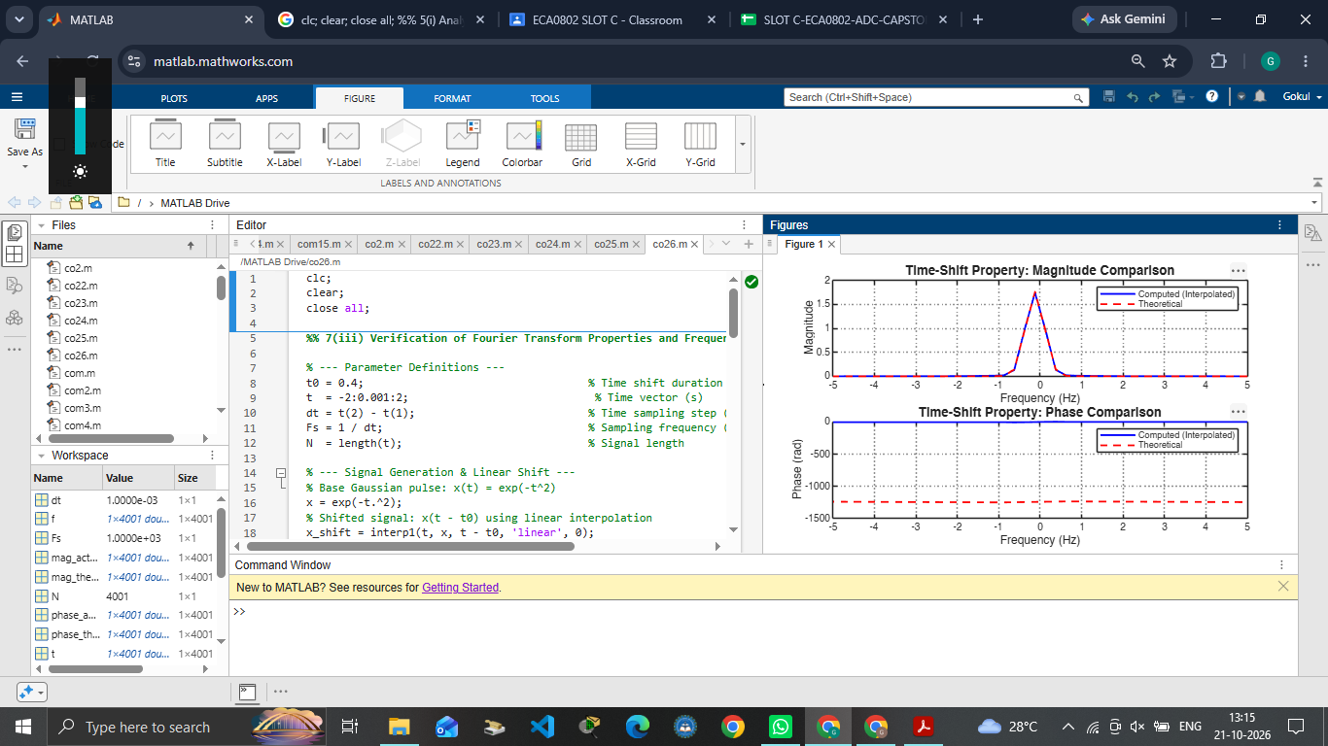
Fig. 7.2 Time-shift property: magnitude and phase comparison (computed vs theoretical)
OUTPUT PARAMETERS (THEORETICAL vs SIMULATED)
S.No. | Output Parameter | Theoretical Value | Simulated Value | % Deviation
1 | Shifted signal | x(t − 0.4) | Gaussian delayed by 0.4 s | Qualitative match
2 | Peak of magnitude spectrum | 1.764 (theoretical transform) | 1.747 (computed) | ≈ 1 %
3 | Magnitude difference (|f| ≤ 5 Hz) | ≈ 0 | Max 0.017 | ≈ 1 % of peak
4 | Phase change | −2πft₀ | Wrapped phase difference ≤ 0.4 rad where |X(f)| > 0.1 | See note

RESULT
The computed and theoretical magnitude spectra of the shifted Gaussian coincide (peak 1.747 against 1.764, about 1 % difference), which verifies that a time shift does not change the magnitude spectrum. In the phase plot the two curves are offset because the unwrapping runs over the full frequency axis (about ±500 Hz), including regions where the spectrum is almost zero; where the spectrum is significant, the wrapped phase difference is within about 0.4 rad, consistent with the added phase of −2πft₀.

LABORATORY PERFORMANCE ASSESSMENT RUBRICS:

Objective | Assessment Criterion | Excellent – 4 | Good – 3 | Satisfactory – 2 | Needs Improvement – 1 | Weightage | Marks(10) | Marks obtained
(ii) To determine the magnitude and phase spectra of continuous-time signals and analyze their significant spectral components. | Fourier Transform Computation & MATLAB Implementation | Computes X(jω) of every given CT signal correctly, analytically and numerically . Uses a suitable time range, sampling rate and frequency axis in rad/s or Hz. | Computes the spectra correctly, with minor errors in scaling, sampling rate, frequency axis or parameters. | Computes the spectra for only some signals, or has noticeable errors in code, scaling or frequency axis, and needs assistance. | Unable to compute the Fourier transform or produce meaningful spectra. | 20 | 2
 | Magnitude & Phase Spectrum Plots | Plots |X(jω)| and ∠X(jω) correctly for every signal, with proper scaling, titles, axis labels and grid. Handles phase wrapping and phase near zero-magnitude points correctly. | Plots both spectra correctly, with minor errors in scaling, labelling, phase wrapping or axis range. | Plots the spectra with noticeable errors in scaling, phase handling or labelling, and needs guidance. | Unable to plot the magnitude and phase spectra. | 20 | 2
 | Spectral Component Analysis | Correctly identifies dominant frequencies, peaks, bandwidth and the frequency range holding most of the signal energy. Uses symmetry (even magnitude, odd phase for real signals) and relates the spectral lines or lobes to the signal parameters. | Identifies most significant spectral components and bandwidth, with minor errors or limited justification. | Identifies only basic spectral components. Bandwidth or symmetry reasoning is incomplete, and needs guidance. | Unable to identify or justify the significant spectral components. | 20 | 2
 | Analytical vs Numerical Verification | Compares the analytical and MATLAB spectra, quantifies the difference and explains its causes such as truncation, sampling and spectral leakage. Shows how signal parameters change the spectrum. | Compares analytical and numerical results correctly, with brief explanation of differences. | Makes a basic comparison with noticeable errors, and the explanation of differences is incomplete. | Unable to verify the numerical spectra against the analytical results. | 20 | 2
 | Engineering Analysis, Record & Interpretation | Provides technically accurate interpretation of the results and relates them to the physical or engineering meaning of the signal. Maintains a complete, well-organized record with observations, tables, plots and conclusions. | Maintains a proper record with correct interpretation, with minor omissions in explanation or conclusions. | Record and interpretation are partial or only descriptive, and need guidance. | Incomplete record, limited or incorrect interpretation of the results. | 20 | 2
 |  |  |  |  | Total | 100 | 10

